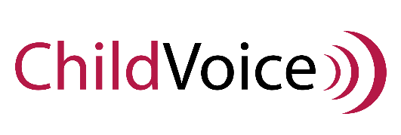
1st Annual ChildVoice Golf Tournament
Sponsor Form
Name: _________________________________________
Company Name: _________________________________
Sponsorship level:
☐ Title Sponsor $5,000
☐ Lunch Sponsor $2,500
☐ Driving Range $450
☐ Closest to Pin $250
☐ Longest Drive $250
☐ Hole Sponsor $250
☐ Friend of ChildVoice $100
Address: _____________________________________________________________________________
_____________________________________________________________________________________
☐ Yes, please add my address to the mailing list
Phone: (______)___________________
Email: ____________________________________________
☐ Yes, please send me monthly email updates from ChildVoice
Please mail this completed form and check to:
ChildVoice
202 Kent Place
Newmarket, NH 03857
Questions?
Contact Krista Brown, Donor Relations Coordinator, at 603.842.0132
or email krista.brown@childvoiceintl.org
Sponsors:
Please email your logo or graphics to krista.brown@childvoiceintl.org

